

**Total marks**

**/30**

**Year 11 Chemistry**

**Flame Tests Practical Assessment**

**Name**: ______________________

1. List three safety considerations and the corresponding precautions you needed to take in your flame test experiment **(3 marks)**

|  |  |
| --- | --- |
| Potential hazard | Precautions taken to manage risk |
|  |  |
|  |  |
|  |  |

2. Display your observations (from your flame tests conducted in class) in a suitable results table below **(2 marks)**

3. Use diagrams to help explain the principle behind how flame tests can be used to identify elements. **(4 marks)**

4. Explain why no two elements you tested produced exactly the same results. **(2 marks)**

5. Flame tests can be used in a number of applications, from crime scene forensics and blood tests to the chemical analysis of food, agricultural products or medicines. Consider the following scenarios and answer the questions based on your experimental results.

a) Police are conducting tests on the contents of a salt cellar (NaCl) believed to have been deliberately contaminated in a poisoning attempt. Blood samples from the victim have revealed high levels of barium which is toxic when ingested.

i) If the salt is *uncontaminated*, what *colour* would a flame test on the contents produce?  **(1 mark)**

ii) If a barium compound has been added to the salt, what *colour* might be evident in a flame test? **(1 mark)**

b) Suggest two potential problems with using flame tests in cases like those mentioned in part (a). **(2 marks)**

c) In routine flame tests on compounds from imported fireworks, one brand produced lilac, crimson red and blue-green flames. What three cations are most likely to be present? **(3 marks)**

6. The diagrams below show two different ways of analysing the spectrum of the element Hydrogen.

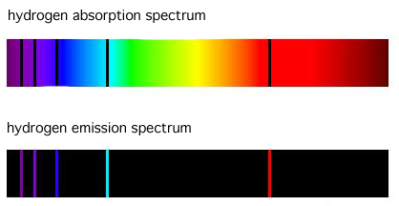

a) Which of these methods is most similar to that which you used to analyse the metal salts? **(1 mark)**

b) By comparing and contrasting atomic absorption spectrometry and atomic emission spectrometry, explain your previous answer **(3 marks)**

7.   Below you will find the known spectra for five common elements followed by the spectrum recorded from a mineral sample. Examine the spectra and answer the questions that follow.

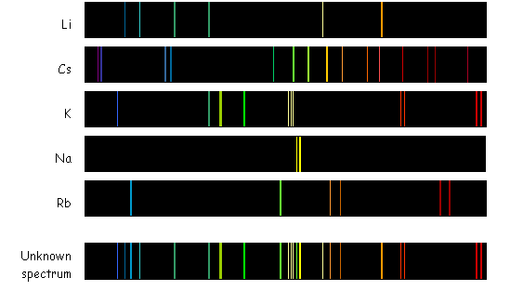

a) Potassium is an element known to be in the unknown sample. How does the spectrum of the unknown sample demonstrate this? **(2 marks)**

b) Which element is *not* in the mineral sample that produced the “unknown spectrum”? How can you tell? **(2 marks)**

8. Some students performed a flame test on an unknown salt. A picture of the result is shown below.

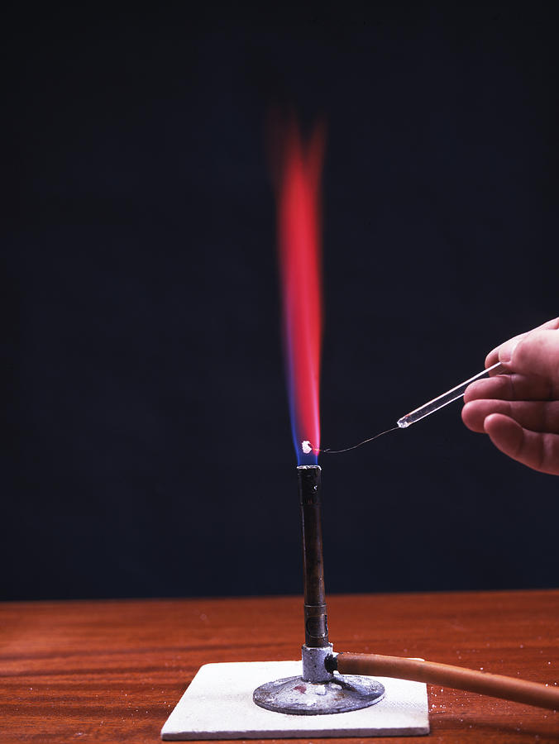

(a) From your results, predict what metal ion is present in this salt. **(1 mark)**

(b) Why would you not be able to use flame tests to distinguish between sodium chloride and sodium sulfate? **(1 mark)**

9. Give two practical or commercial applications of atomic absorption spectroscopy or atomic emission spectroscopy.  **(2 marks)**